Chapter 19, Solution 9.

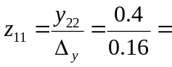 2.5 Ω

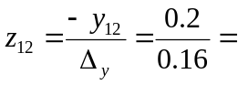 1.25 Ω = z₂₁

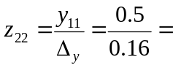 3.125 Ω
Thus,
Z 